VACCINE DISTRIBUTION & MANAGEMENT SYSTEM GROUP

2021

Group Number: 8

Team Members:

Mohit Negi

Ameya Ranade

Abhishek Palkar

Ashay Kanade

Ajinkya Babar

# Content

1. Database Purpose
   1. Business Problems Addressed
   2. Business Rules
2. Design Documents
   1. Chens Relationship Diagram
   2. Data Dictionary
   3. Key Design Decision
3. Entity Relationship Diagram

# Database Purpose:

The purpose of the database model is to generate, process and maintain data to support vaccine distribution over different networks. The database enables coordination and ensures timely administration of vaccines to the intended recipients. It stores information about the vaccine manufacturers, vaccine distributors such as centres, pharmacies, and hospitals, also stores data regarding the patients receiving the vaccine such as which vaccine they have received, the age group they belong to and the location where they live. The database allows the organization to calculate the number of vaccines distributed, number of vaccines required, number of people partially vaccinated, number of people fully vaccinated, affected areas, and ensuring an efficient vaccine delivery.

# Business Problems Addressed:

The following business problems are addressed by the database model:

* The database model maintains the information about the availability of vaccines at vaccination centres, hospitals and pharmacies.
* Stores the inventory records of different vaccines available at vaccination centres, hospitals and pharmacies.
* Stores data from the Purchase Department and the Inventory Department of the vaccination distribution location.
* Records are maintained about the purchase orders of vaccines by the vaccination distribution location.
* Also stores information regarding different vaccine manufacturers that supply vaccines to the distribution locations.
* Stores a record of the details of the vaccine recipient, along with the date of receiving first and second dosage.
* Enables area admin manages and facilitates the distribution of vaccines in a particular area.
* Provides recipients with the information regarding the vaccine manufacturer and distribution locations.
* It allows tracking of the number of vaccines administered, along with the number of dosages received by each recipient in a particular area.
* Enables storage of customer feedback for each dosage received.
* Stores tracking information for the delivery of purchase orders made by a distribution locations.
* Helps abridge the complexity between distribution locations and the recipients in a particular area.

# Business Rules:

* Each recipient has a unique residential address and a single contact number.
* Each area admin must log in with unique login credentials to manage the operations for that area.
* Each distribution location receives one or more orders from multiple vaccine manufacturers.
* The availability of vaccines varies from area to area.
* Each distribution location is allowed to place a single order at a time from a single vaccine manufacturer.
* Each recipient can receive only two dosages of the same vaccine.
* Each dosage received by a recipient must have a minimum of 21 days gap.
* If vaccine V1 is available in area A1, and v1 is also known to be available in the pharmacies of division A, it can be inferred that the pharmacies in area A1 have vaccine v1 available.

# Design Document:

## **Chens Relationship Diagram**

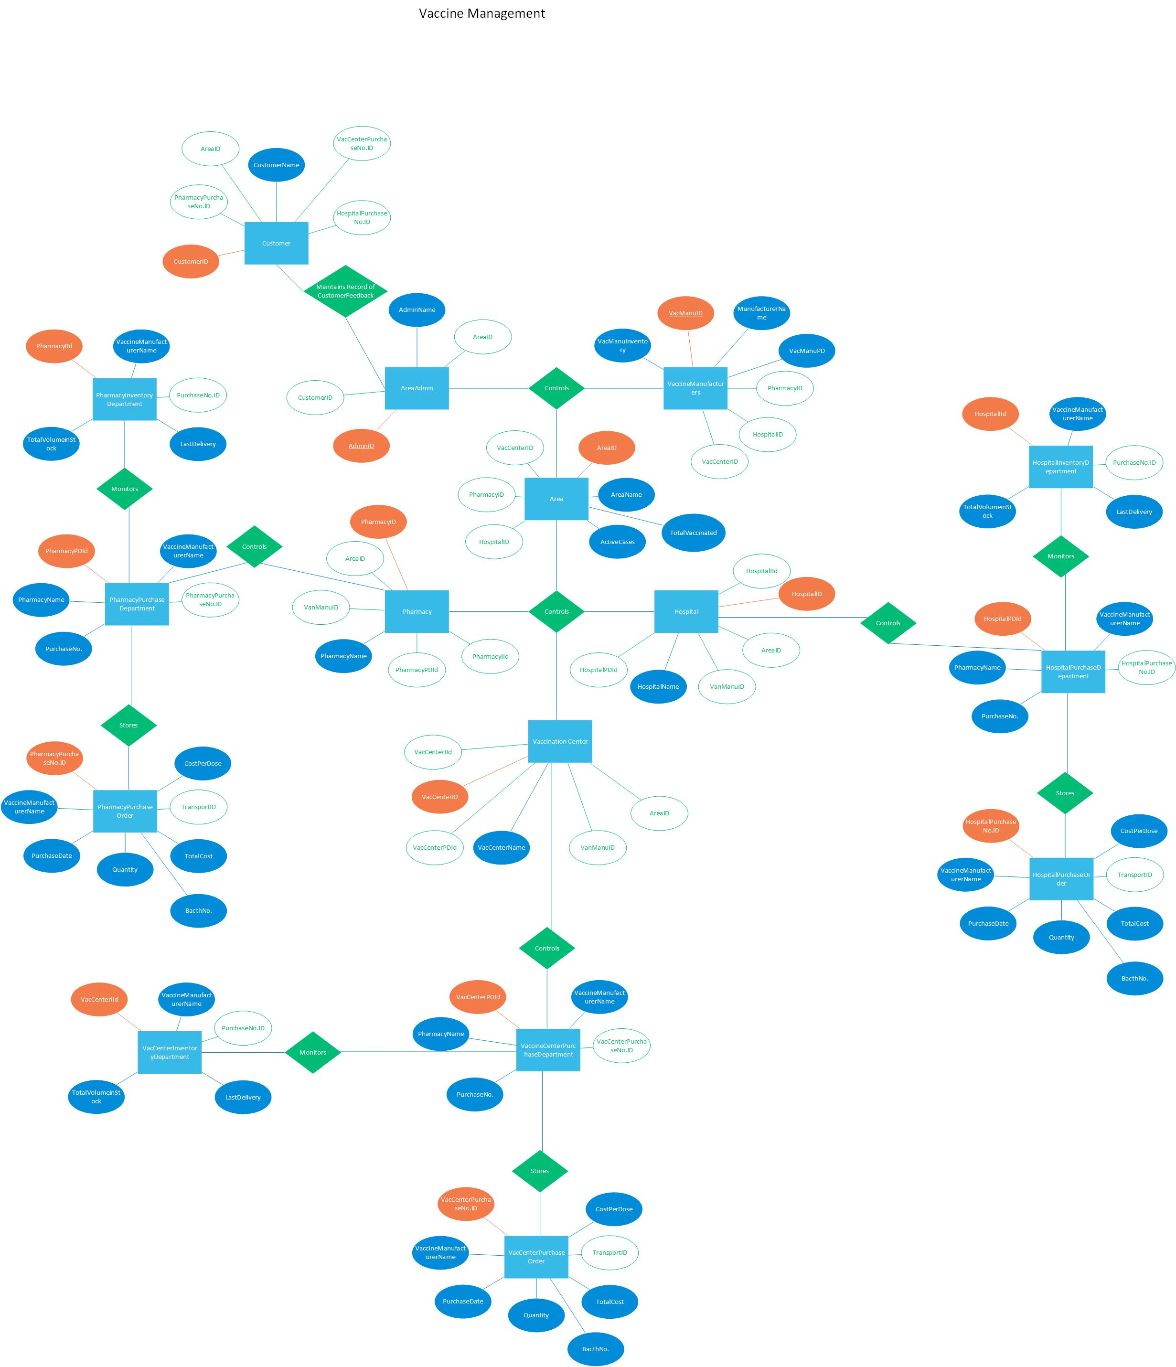

**Fig-1:** Chens Entity Relationship Diagram

|  |  |  |  |
| --- | --- | --- | --- |
| Database Dictionary: |  |  |  |
| **Entity** | **Description** | **Alias** | **Occurrence** |
| AreaAdmin | General term describing all the area administrators | AdminID | Each member of AreaAdmin is assigned multiples areas to administor |
| Area | Giving information about the covid impact on the area | AreaID | Each area is assigned specific vaccine manufacturers but the area admin can assign multiple vaccines to same area based on cases. |
| AreaVaccineDistribution | A lookup table containing address of pharmacy, hospitals and vaccination centers | LookupID | Each lookup table containes address to unique pairs of pharmacy-vaccine manufacturer, hospital-vaccine manufacturer & vaccination centers - vaccine manufacturers |
| VaccineManufacturer | Describes the vaccine manufacturer properties | VacManu | Each vaccnination manufacturer can supply to multiple areas |
| Pharmacy | General term describing all the pharmacy administrators | PharmacyID | Each pharmacy admin has single vaccine available |
| PharmacyPurchaseDepartment | Provides information about the purchases made by the pharmacy | PharmacyPDId | Each PhPD can request vaccine from a single manufacturer at a time. |
| PharmacyInventoryDepartment | Keeps upto date inventory for the pharmacy | PharmacyIId | Each PhID must maintain a single vaccine manufacturer inventory. |
| PharmacyPurchaseOrder | Keeps the records of specific batch of vaccine delivered to the pharmacy | PharmacyPurchaseNo.ID | Each Purchase order contains a uniqe batch of vaccine discription |
| Hospital | General term describing all the hospital administrators | HospitalID | Each hospital has single vaccine available |
| HospitalPurchaseDepartment | Provides information about the purchases made by the hospital | HospitalPDId | Each HPD can request vaccine from a single manufacturer at a time. |
| HospitalInventoryDepartment | Keeps upto date inventory for the hospitals | HospitalIId | Each HID must maintain a single vaccine manufacturer inventory. |
| HospitalPurchaseOrder | Keeps the records of specific batch of vaccine delivered to the hospital | HospitalPurchaseNo.ID | Each Purchase order contains a uniqe batch of vaccine discription |
| VaccinationCenter | General term describing all the vaccination center administrators | VacCenterID | Each vaccination center can have multiple vaccine available |
| VacCenterPurchaseDepartment | Provides information about the purchases made by the vaccination center | VacCenterPDId | Each VacPD can request vaccine from multiple manufacturer at a time. |
| VacCenterInventoryDepartment | Keeps upto date inventory for the vaccination centers | VacCenterIId | Each VacID must maintain multiple vaccine manufacturer inventory. |
| VacCenterPurchaseOrder | Keeps the records of specific batch of vaccine delivered to the vaccination center | VacCenterPurchaseNo.ID | Each Purchase order contains a uniqe batch of vaccine discription |
| Customer | General term describing all the customer feedback  **Table-1:** Database Dictionary | CustomerID | Each CustFeed must be for a single vaccine manufacturer |

# Key Design Decisions:

**Table-3:** Distributor-wise vaccine manufacturer availability (Initial Design)

|  |  |  |  |  |  |
| --- | --- | --- | --- | --- | --- |
| Division | Delivery\Vaccine | V1 | V2 | V3 | V4 |
| A | Pharmacy | Y | - | - | - |
| Hospital | Y | - | Y | - |
| Center | Y | Y | Y | - |
| M | Pharmacy | Y | Y | - | - |
| Hospital | - | Y | - | Y |
| Center | Y | Y | - | Y |
| B | Pharmacy | - | Y | Y | Y |
| Hospital | - | - | Y | Y |
| Center | Y | Y | - | Y |
| C | Pharmacy | Y | Y | Y | Y |
| Hospital | Y | Y | Y | Y |
| Center | Y | Y | Y | Y |
| L | Pharmacy | - | - | - | - |
| Hospital | Y | - | Y | - |
| Center | - | Y | - | Y |

|  |  |  |  |  |
| --- | --- | --- | --- | --- |
| Area\Vaccine | V1 | V2 | V3 | V4 |
| A1 | Y | Y | - | - |
| A2 | Y | - | - | - |
| A3 | Y | Y | - | - |
| A4 | - | - | Y | - |
| M1 | Y | - | - | - |
| M2 | Y | Y | - | - |
| M3 | Y | Y | - | Y |
| B1 | Y | Y | Y | - |
| B2 | - | - | Y | Y |
| B3 | - | - | Y | - |
| B4 | - | - | Y | - |
| B5 | - | Y | - | Y |
| B6 | - | - | - | Y |
| C1 | Y | Y | Y | - |
| C2 | - | Y | - | - |
| C3 | - | - | - | Y |
| C4 | - | - | - | Y |
| C5 | Y | Y | Y | Y |
| C6 | - | - | - | Y |
| C7 | Y | Y | Y | - |
| C8 | Y | - | - | - |
| L1 | Y | Y | Y | Y |
| L2 | Y | Y | Y | Y |
| L3 | - | - | Y | - |

**Table-2:** Area-wise vaccine availability (Initial Design)

|  |  |  |  |  |  |
| --- | --- | --- | --- | --- | --- |
| Area | Delivery\Vaccine | V1 | V2 | V3 | V4 |
| A1 | Pharmacy | Y | - | - | - |
| Hospital | Y | Y | - | - |
| Center | Y | - | - | - |
| A2 | Pharmacy | Y | - | - | - |
| Hospital | Y | - | - | - |
| Center | Y | - | - | - |
| A3 | Pharmacy | Y | - | - | - |
| Hospital | Y | Y | - | - |
| Center | Y | - | - | - |
| A4 | Pharmacy | - | - | - | - |
| Hospital | - | - | - | - |
| Center | - | - | - | - |
| M1 | Pharmacy | Y | - | - | - |
| Hospital | Y | - | - | - |
| Center | Y | - | - | - |
| M2 | Pharmacy | Y | - | - | - |
| Hospital | Y | - | - | - |
| Center | Y | - | - | - |
| M3 | Pharmacy | Y | - | - | - |
| Hospital | Y | - | - | - |
| Center | Y | - | - | - |
| B1 | Pharmacy | Y | - | - | - |
| Hospital | Y | Y | - | - |
| Center | - | - | - | - |
| B2 | Pharmacy | - | - | - | - |
| Hospital | - | - | - | - |
| Center | - | - | - | - |
| B3 | Pharmacy | - | - | - | - |
| Hospital | - | - | - | - |
| Center | - | - | - | - |
| B4 | Pharmacy | - | - | - | - |
| Hospital | - | - | - | - |
| Center | - | - | - | - |
| B5 | Pharmacy | - | - | - | - |
| Hospital | - | Y | - | - |
| Center | - | - | - | - |
| B6 | Pharmacy | - | - | - | - |
| Hospital | - | - | - | - |
| Center | - | - | - | - |

|  |  |  |  |  |  |
| --- | --- | --- | --- | --- | --- |
| C1 | Pharmacy | - | - | Y | - |
| Hospital | - | - | Y | - |
| Center | Y | - | - | - |
| C2 | Pharmacy | - | - | - | - |
| Hospital | - | - | - | - |
| Center | - | - | - | - |
| C3 | Pharmacy | - | - | - | - |
| Hospital | - | - | - | - |
| Center | - | - | - | - |
| C4 | Pharmacy | - | - | - | - |
| Hospital | - | - | - | - |
| Center | - | - | - | - |
| C5 | Pharmacy | - | - | Y | - |
| Hospital | - | - | Y | - |
| Center | Y | - | - | - |
| C6 | Pharmacy | - | - | - | - |
| Hospital | - | - | - | - |
| Center | - | - | - | - |
| C7 | Pharmacy | - | - | Y | - |
| Hospital | - | - | Y | - |
| Center | Y | - | - | - |
| C8 | Pharmacy | - | - | - | - |
| Hospital | - | - | - | - |
| Center | Y | - | - | - |
| L1 | Pharmacy | - | - | - | - |
| Hospital | Y | - | - | - |
| Center | Y | Y | - | - |
| L2 | Pharmacy | - | - | - | - |
| Hospital | Y | - | - | - |
| Center | Y | Y | - | - |
| L3 | Pharmacy | - | - | - | - |
| Hospital | - | - | - | - |
| Center | - | - | - | - |

# 

**Table-4 :** Final Relationship based on Table-2 & Table-3

# Entity Relationship Diagram:

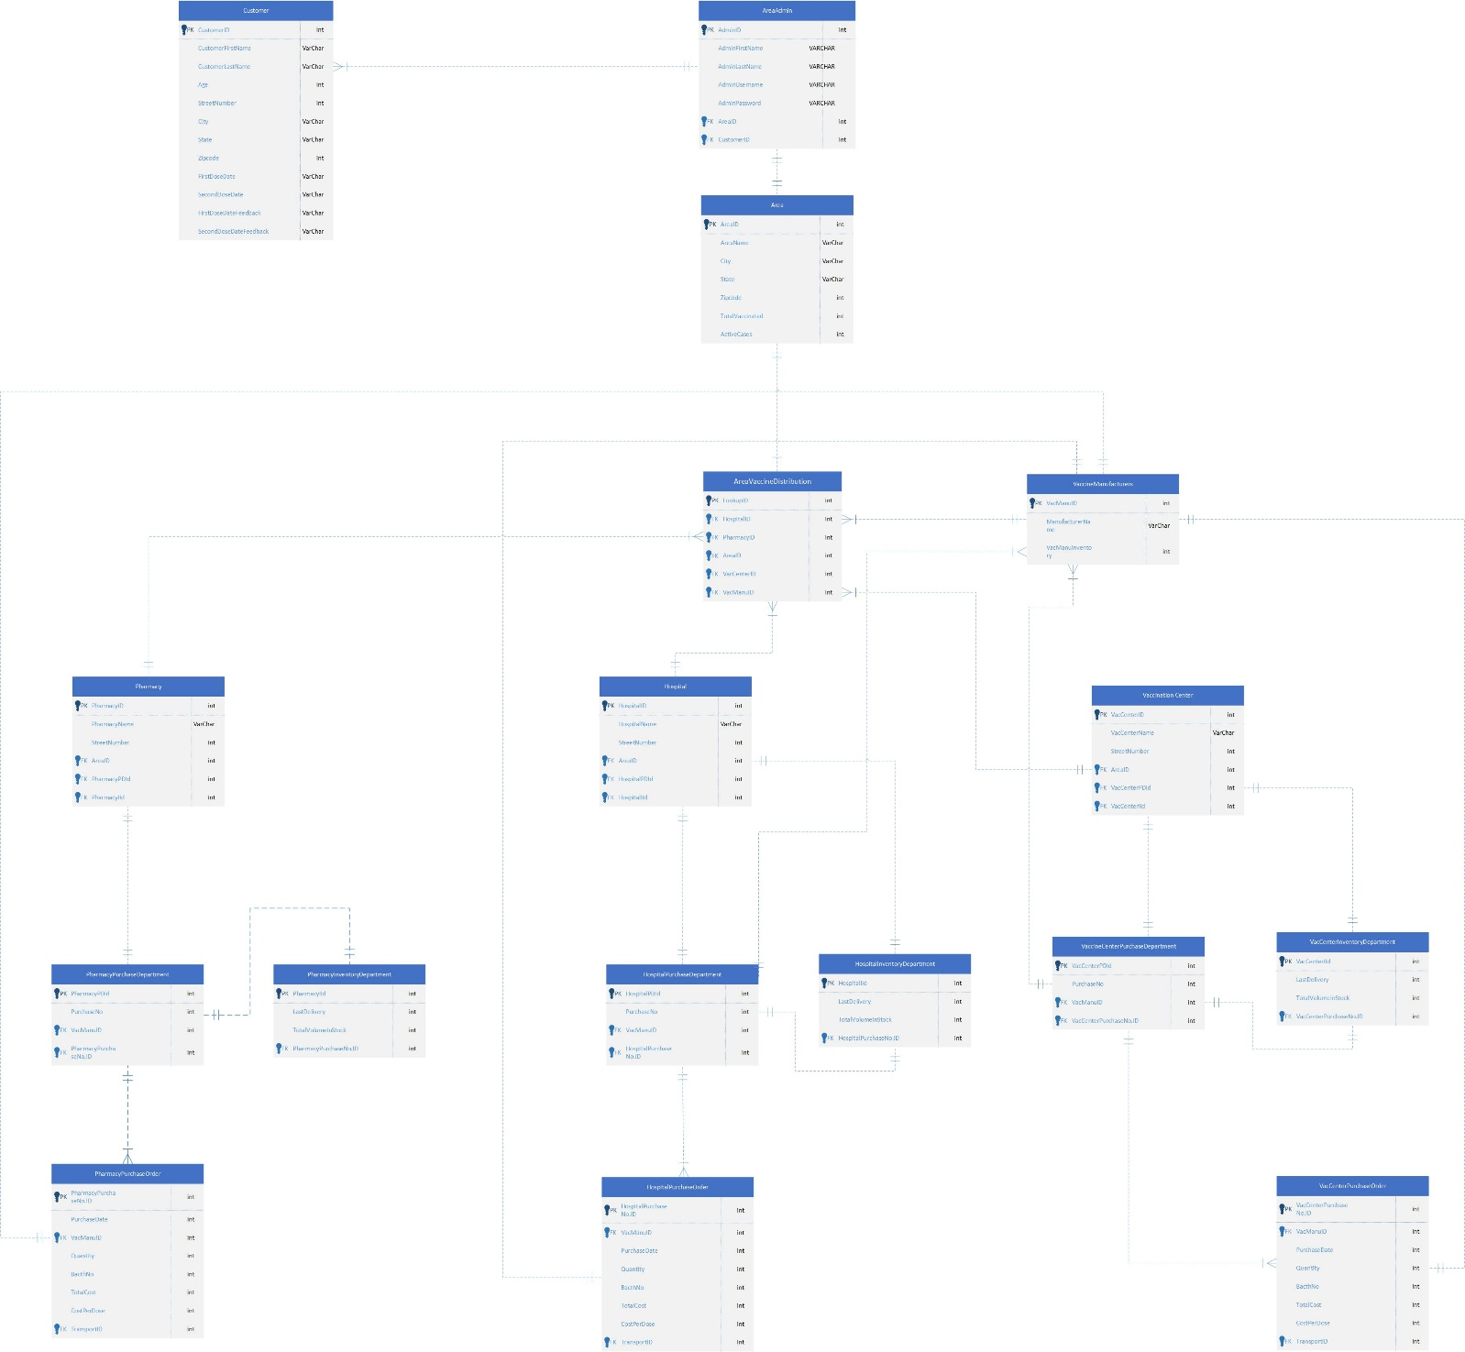

**Fig-2:** Entity Relationship Diagram (Crow-Foot Notation)